**Lab 4.3**

***How could you rewrite gpa >= 2.0 in the first if statement using the NOT operator?***

Yes. if (!(gpa < 2.0) && year == '4')

***Could you replace year !='4' in the else if statement with year < 4 or year <= 3? Why or why not?***

Yes it’s a nice replacement. In fact, <4 and <=3 work much better than !='4', because this last one admits a result above 5 (because 5 and above are not equal to 4), whereas <4 and <=3 do not.

***Take a screen shot of the output.***

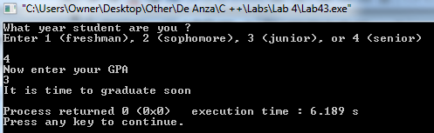

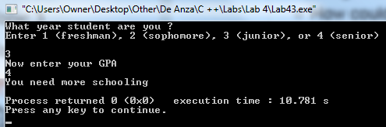

***if you replace***

***if ( gpa >= 2.0 && year == '4') with if ( gpa >= 2.0 || year == '4') and replace else if ( year != '4'|| gpa < 2.0) with else if ( year != '4' && gpa < 2.0) which students will graduate and which will not graduate according to this new program? Does this handle all cases (i.e., all combinations of year and gpa)?***

The Students that would graduate would be those that have either a gpa above 2.0 (even if they're in their first year, or have been in school for 4 years (even if their GPA below 2.0). Those who have neither wouldn't graduate. And yes, it does handle all cases (even if incorrectly).

***Take a screen shot of the output. Insert it in LastFirst_lab43.doc.***

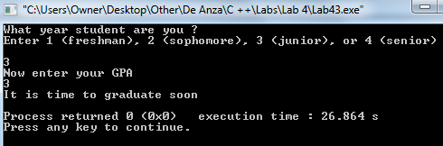

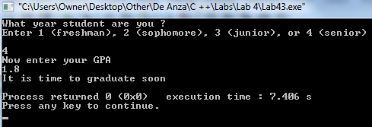

***Could you replace else if ( year != '4'|| gpa < 2.0) with the single word else?***

If I remove the expression ***else if ( year != '4'|| gpa < 2.0)*** and replace it for a mere ***else***, this would be a good replacement (it works fine).

***Take a screen shot of the output. Insert it in LastFirst_lab43.doc.***

